IPL ANALYSIS DAX FORMULAS

1)SEASON WINNER

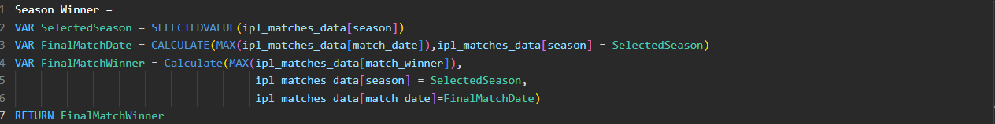

2) SEASON WINNER LOGO

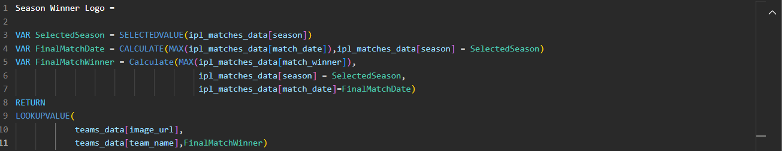

3) RUNNER UP

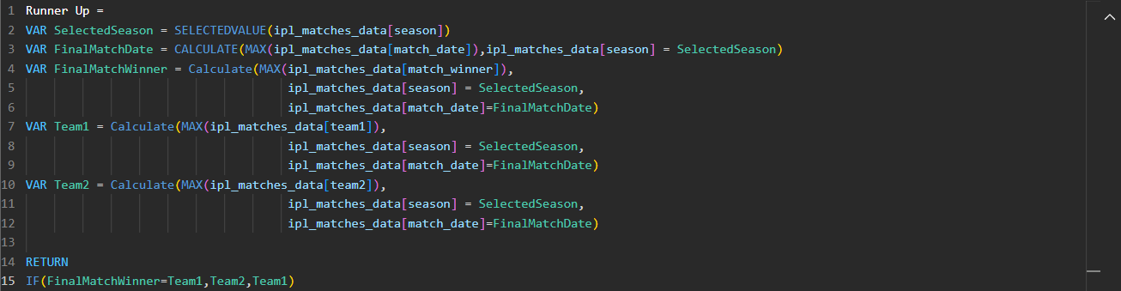

4) RUNNER UP LOGO

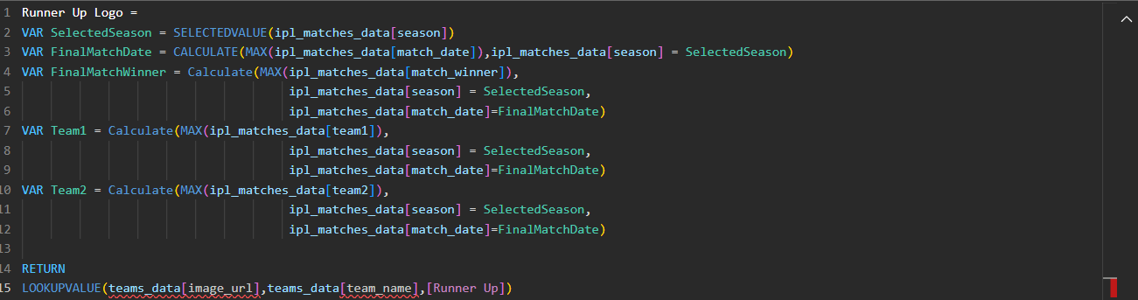

5) TOTAL 6’S



6) TOTAL 4’S



7) TOTAL MATCHES PLAYED



8) TOTAL TEAMS



9) CENTURIES

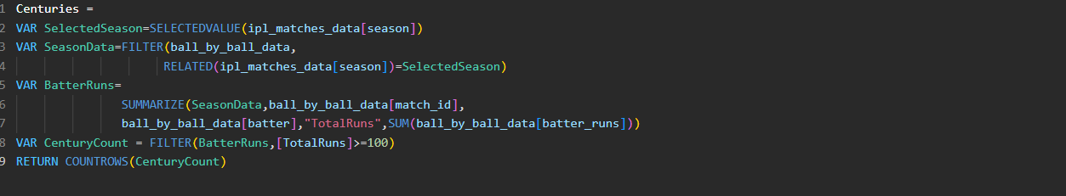

10) HALF CENTURIES

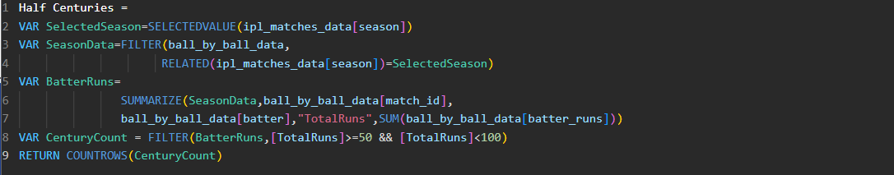

11) TOTAL VENUES



12) ORANGE CAP HOLDER  
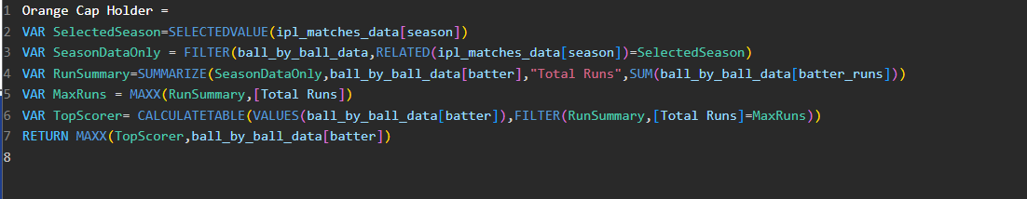

13) ORANGE CAP IMAGE

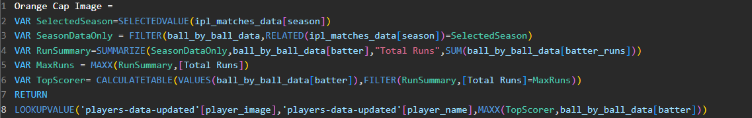

14) ORANGE CAP RUNS

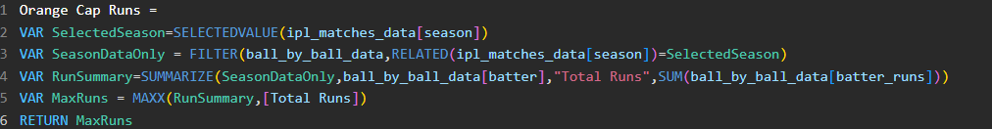

15) ORANGE CAP TEAM NAME

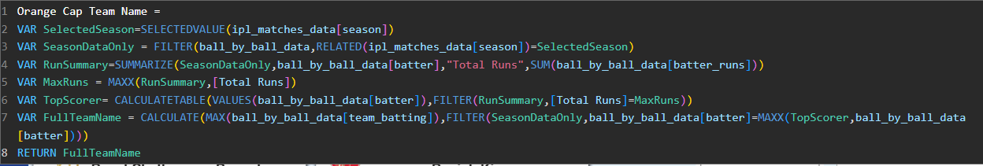

16) PURPLE CAP HOLDER

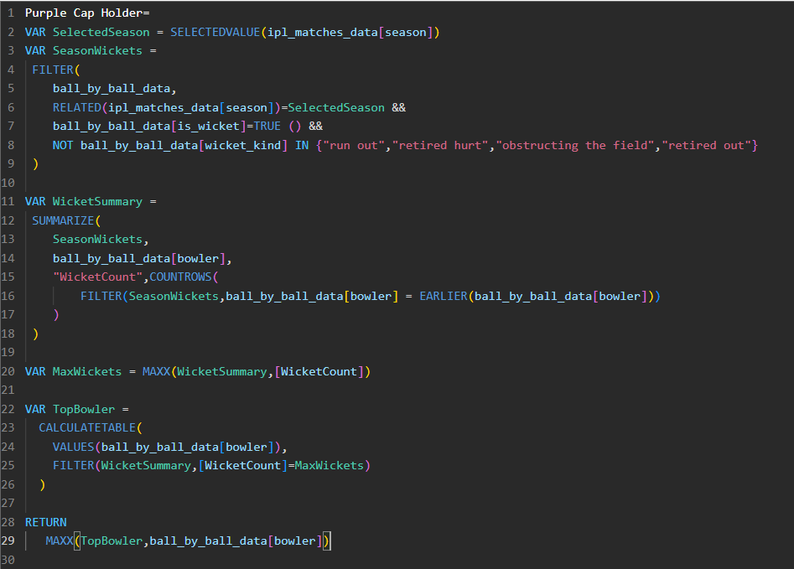

17) PURPLE CAP WICKET COUNT

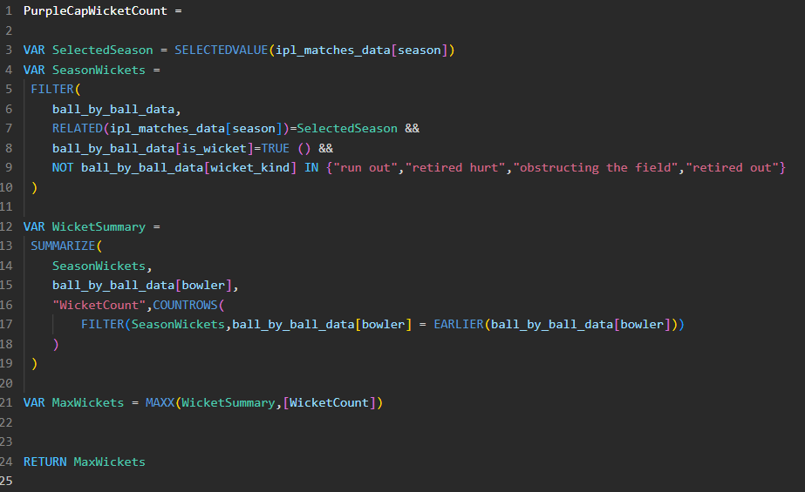

18)PURPLE CAP TEAM

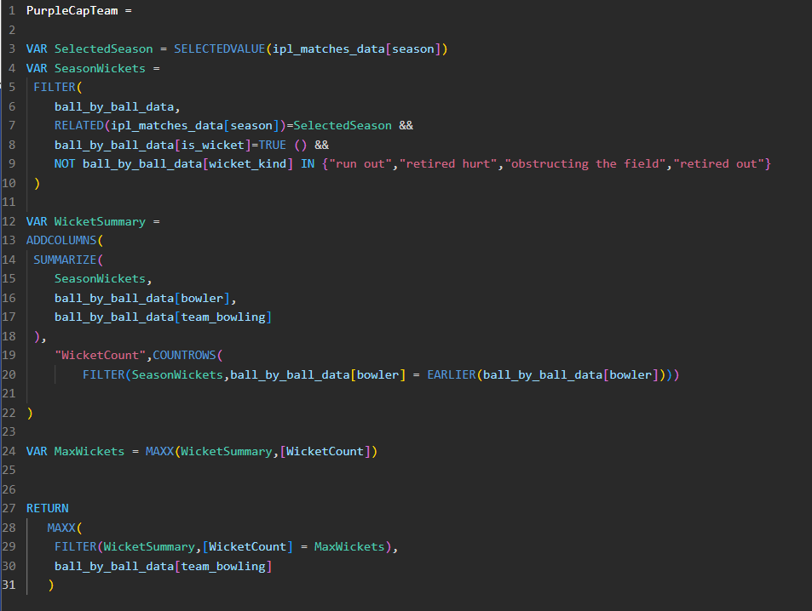

19PURPLE CAP IMAGE

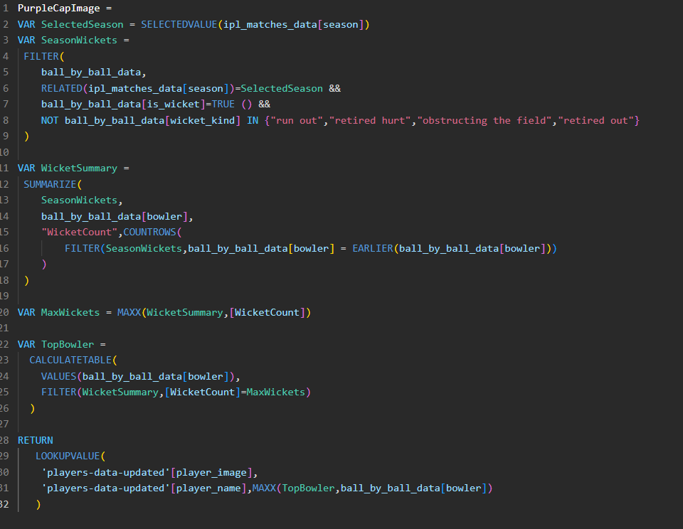

20) TOP FOURS PLAYER NAME

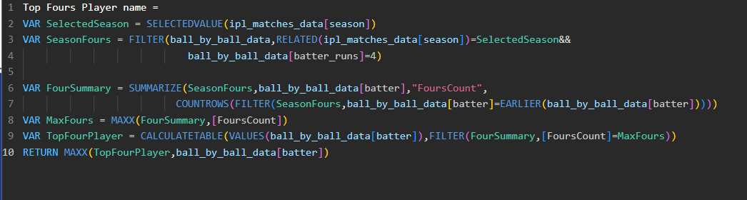

21) TOP FOUR PLAYER’S TEAM NAME

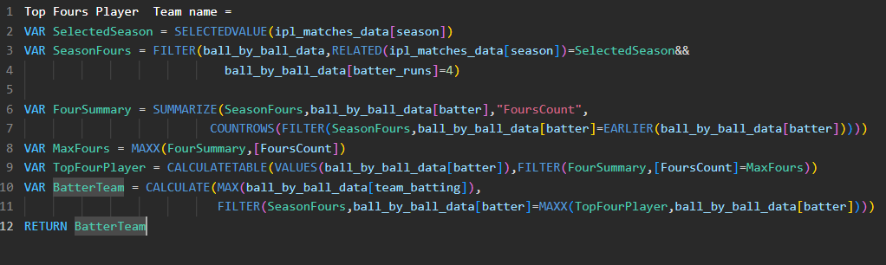

22) TOP FOURS COUNT

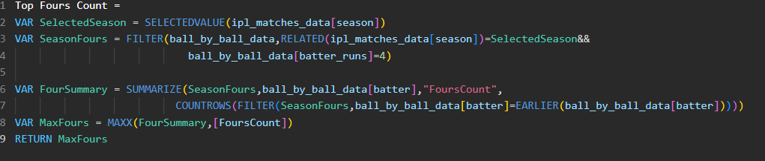

23) TOP FOURS PLAYER IMAGE

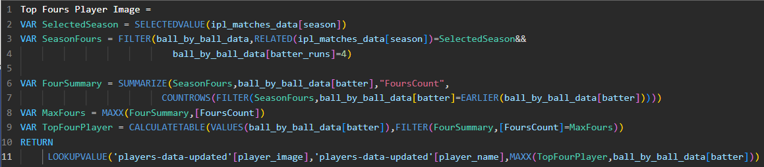

24) TOP SIX PLAYER NAME

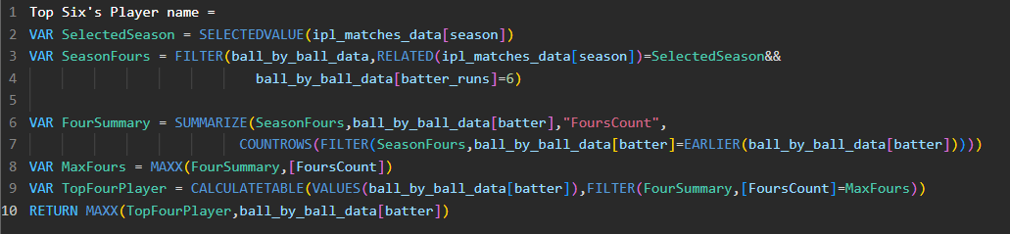

25)TOP SIX COUNT

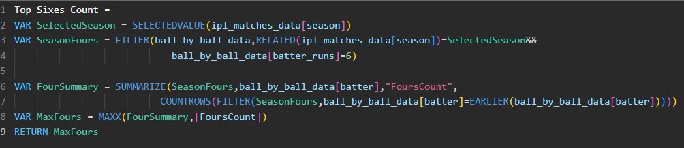

26) TOP SIX PLAYER’S TEAM NAME

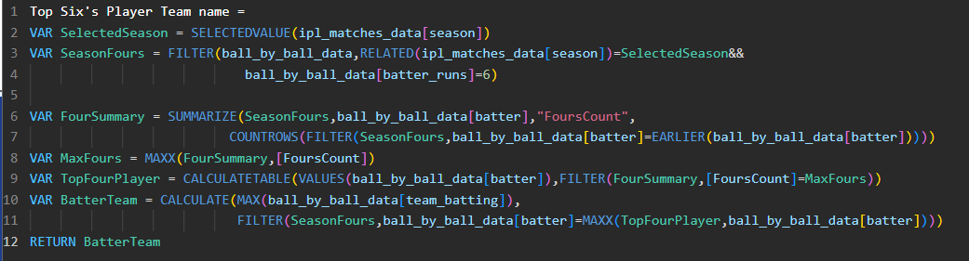

27) TOP SIX PLAYER IMAGE

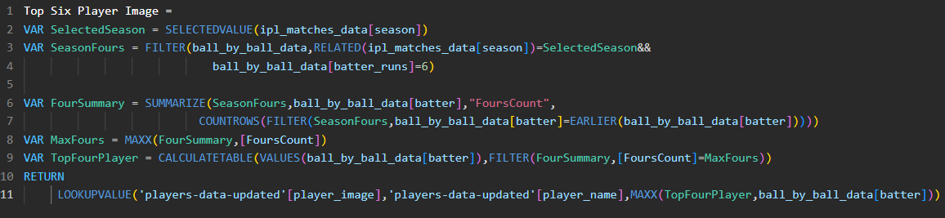

POINTS TABLE

28)MATCHES PLAYED

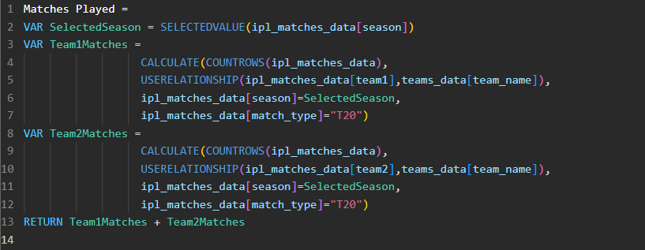

29) MATCHES WON

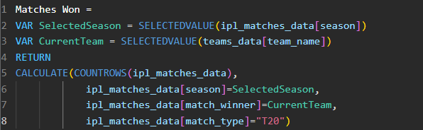

30) MATCHES LOST

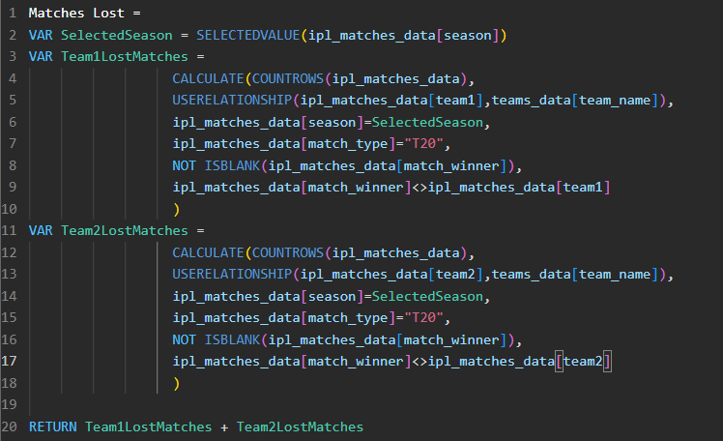

31) NO RESULT MATCHES

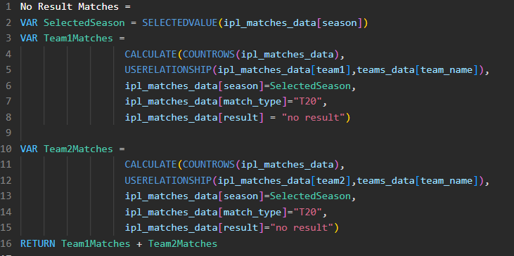

32)MATCHES TIED

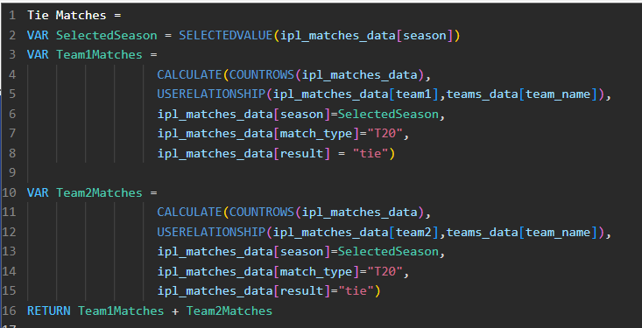

33) TOTAL POINTS

